**ROXON E COMMERCE WEBSITE**

A MINI-PROJECT REPORT

*Submitted by*

B. ADITHYA SINGH 211701010

HIRESH V BERIA 211701020

*in partial fulfilment for the course*

# CD19643 – WEB ESSENTIALS

*for the degree of*

## BACHELOR OF ENGINEERING in COMPUTER SCIENCE AND DESIGN

RAJALAKSHMI ENGINEERING COLLEGE RAJALAKSHMI NAGAR

THANDALAM CHENNAI - 602 105

MAY 2024

**RAJALAKSHMI ENGINEERING COLLEGE CHENNAI - 602105**

**BONAFIDE CERTIFICATE**

Certified that this project report **“ROXON FOOTWEAR WEBSITE”** is the bonafide work of **“B. ADITHYA SINGH (211701010), HIRESH V BERIA (211701020)** who carried out the project work for the subject CD19643 – Web Essentials under my supervision.

**SIGNATURE SIGNATURE**

**Prof. Uma Maheshwar Rao , Dr.N.Duraimurugan,M.Tech.,Ph.D., Head of the Department Supervisor**

Associate Professor Assistant Professor

Department of Computer Science and Department of Computer Science and

Design Engineering

Rajalakshmi Engineering College Rajalakshmi Engineering College Chennai - 602105 Chennai - 602105

Submitted to Project and Viva Voce Examination for the subject CD19643 – Web Essentials held on .

Internal Examiner External Examiner

**INDEX**

**CHAPTER NO.**

**TITLE PAGE**

**NO.**

ABSTRACT 4

ACKNOWLEDGEMENT 5

1. INTRODUCTION 6
2. OBJECTIVE 7
3. FUNCTIONAL OVERVIEW 9
4. TECHNICAL IMPLEMENTATION 11
5. OUTPUT 15
6. CONCLUSION 18

REFERENCES 19

# ABSTRACT

In the digital age, e-commerce has emerged as a pivotal platform for businesses to reach global audiences and redefine shopping experiences. This abstract presents a comprehensive analysis of the transformational journey undertaken by ROXON Footwear brand in establishing its online presence through a dedicated e-commerce website.

The ROXON Footwear brand's website serves as a prime example of leveraging technology to create a seamless and engaging shopping environment. Through a combination of user-centric design, intuitive navigation, and personalized recommendations, the website aims to enhance the customer journey from browsing to checkout.

Key elements of the website's design include visually appealing product displays, intuitive search functionalities, and efficient filtering options to cater to diverse consumer preferences. Moreover, the integration of secure payment gateways and streamlined checkout processes ensures a hassle-free transaction experience, fostering trust and loyalty among customers.

Furthermore, the website incorporates robust backend systems for inventory management, order processing, and customer relationship management, enabling the brand to efficiently handle operations and deliver exceptional service standards.

# ACKNOWLEDGEMENT

Initially we thank the Almighty for being with us through every walk of our life and showering his blessings through the endeavour to put forth this report. Our sincere thanks to our Chairman **Mr.S.Meganathan, B.E, F.I.E.,** our Vice Chairman **Mr. Abhay Shankar Meganathan, B.E., M.S.,** and our respected Chairperson **Dr. (Mrs.) Thangam Meganathan, Ph.D.,** for providing us with the requisite infrastructure and sincere endeavouring in educating us in their premier institution.

Our sincere thanks to **Dr. S.N.Murugesan, M.E., Ph.D.,** our beloved Principal for his kind support and facilities provided to complete our work in time. We express our sincere thanks to our **Prof. Uma Maheshwar Rao** Associate Professor and Head of the Department of Computer Science and Design for his guidance and encouragement throughout the project work. We convey our sincere thanks to our internal

guide and Project Coordinator, Dr.N**. Duraimurugan, M.Tech., PhD.,**

Department of Computer Science and Engineering, Rajalakshmi

Engineering College for his valuable guidance throughout the course of the project.

B. ADITHYA SINGH (211701010)

HIRESH V BERIA (211701020)

# CHAPTER 1 INTRODUCTION

In the digital era, e-commerce websites have become essential for Footwear brands to reach broader audiences and enhance customer experiences. This introduction explores the development of an e-commerce website for a Footwear brand, showcasing how technology facilitates seamless and engaging online shopping. The website employs user-centric design principles and personalized recommendations to improve the customer journey from browsing to checkout. Key features include attractive product displays, efficient search and filtering options, secure payment gateways, and streamlined checkout processes. Additionally, robust backend systems for inventory management, order processing, and customer relationship management enable the brand to deliver high service standards, ensuring customer satisfaction and fostering loyalty in the competitive online retail market. e-commerce has revolutionized the way Footwear brands connect with consumers, offering a global platform to enhance shopping experiences.

This introduction examines the establishment of a ROXON Footwear brand's e-commerce website, highlighting the integration of advanced technologies to create an engaging and seamless online shopping environment. The website is designed with a focus on user experience, featuring visually appealing product displays, intuitive navigation, and personalized recommendations. These elements aim to enhance the customer journey from browsing to checkout. Secure payment gateways and a streamlined checkout process ensure hassle-free transactions, while robust backend systems for inventory management, order processing, and customer relationship management support efficient operations. By leveraging these technologies, the Footwear brand not only meets the evolving demands of digital consumers but also fosters customer trust and loyalty, positioning itself strongly in the competitive online

# CHAPTER 2 OBJECTIVE

The primary objective of our ROXON website, built using React,

CSS, MongoDB, and Express, is to provide users with a comprehensive and user-friendly platform and to provide a seamless and engaging online shopping experience that maximizes customer satisfaction and drives sales This involves several key goals:

1. **Enhancing User Experience**: Offering a visually appealing, easy-to-navigate platform that allows customers to find and purchase products effortlessly.
2. **Showcasing Products Effectively**: Using high-quality images, detailed descriptions, and videos to present the Footwear items in an attractive and informative manner
3. **Personalizing Shopping Experience**: Leveraging data analytics to offer personalized recommendations and tailored promotions, thereby increasing customer engagement and conversion rates.
4. **Efficient Operations Management**: Utilizing robust backend systems for inventory management, order processing, and customer relationship management to maintain operational efficiency and high service standards.
5. **Building Customer Trust and Loyalty**: Ensuring all transactions are secure to build customer

ROXON footwear website are to enhance user experience, showcase products effectively, provide personalized recommendations, ensure secure and streamlined transactions, manage operations efficiently, and build customer loyalty. These objectives aim to maximize customer satisfaction, drive sales, and foster long-term brand loyalty.

# CHAPTER 3 FUNCTIONAL OVERVIEW

The main purpose of the e-commerce footwear website, ROXON, is to provide customers with a seamless and engaging online shopping experience for high-quality footwear. ROXON aims to showcase its diverse range of products through visually appealing displays, detailed descriptions, and customer reviews

**Frontend Development with React:** Our frontend is developed using React, a popular JavaScript library for building user interfaces. React allows us to create dynamic and interactive components, ensuring a responsive and engaging user experience. With React, users can easily navigate the website, access features, and interact with their workout data.

**Styling normal CSS:** Normal CSS styling involves defining styles for HTML elements using properties such as color, font-size, margin, padding, and background. It ensures consistent design across a website by specifying layouts, fonts, and colors. CSS selectors target elements, classes, and IDs to apply these styles, enhancing the visual appeal and usability of webpages.

**State management using redux:** State management using Redux involves creating a centralized store to manage application state. Actions describe changes, reducers update the state based on actions, and the store holds the entire state tree. Redux simplifies state management in complex applications by providing predictable state updates, enhancing debugging, and enabling easier state sharing across components.

**Visual studio code:** Visual Studio Code is a versatile, open-source code editor developed by Microsoft. It supports multiple programming languages, offers features like syntax highlighting, intelligent code completion, debugging, and Git integration. With extensive extensions and customizable settings, it provides a powerful, efficient environment for developers to write, test, and manage their code.

# CHAPTER 4 TECHNICAL IMPLEMENTATION

Our workout tracker website is built using a combination of React for the frontend, Tailwind CSS for styling, MongoDB for data storage, and Express.js for the backend. This technical stack provides a robust foundation for creating a scalable, responsive, and feature-rich application. Below is an overview of the technical implementation details:

## Frontend Development with React:

We utilize React, a JavaScript library for building user interfaces, to create the frontend of our website.React components are organized hierarchically to manage the UI structure and functionality efficiently.

We implement routing using React Router to enable navigation between different pages and views within the application.State management is handled using React's built-in state and context APIs, allowing for efficient data management and component synchronization.

**Styling normal ss:**

Styling with normal CSS involves applying design rules to HTML elements using properties like color, font-size, margin, padding, and background. Selectors, including element names, classes, and IDs, target specific elements for styling. This process ensures a consistent and visually appealing layout across web pages, improving the overall user experience and aesthetics. Tailwind's extensive set of utility classes allows for precise control over typography, spacing, colors, and more, resulting in a consistent and visually appealing design

## State management - redux:

Redux is a predictable state container for JavaScript applications. It manages the application's state in a single immutable store, accessible by all components. Actions trigger state changes, and reducers modify the state based on these actions, ensuring predictability and ease of debugging. Redux simplifies complex state management by centralizing state logic, enabling time-travel debugging, and facilitating state sharing across components. It's widely used in large-scale applications, offering a scalable and efficient solution for managing application state and enabling better organization, consistency, and maintainability in codebases.

**Visual studio code:**

Visual Studio Code (VS Code) is a lightweight, powerful source code editor developed by Microsoft. With its intuitive interface and extensive features, VS Code has become one of the most popular choices among developers across various platforms. Its versatility stems from support for numerous programming languages and frameworks, facilitated by a rich ecosystem of extensions and plugins.

VS Code offers a plethora of productivity-enhancing features, including syntax highlighting, code completion, and intelligent code suggestions, which streamline the coding process and boost developer efficiency. Additionally, built-in Git integration simplifies version control, allowing seamless collaboration and code management.

One of VS Code's standout features is its customizable nature, allowing developers to tailor the editor to their specific needs. From themes and keybindings to snippets and debugging configurations, users can personalize their workspace for optimal productivity.

# CHAPTER 5 OUTPUT

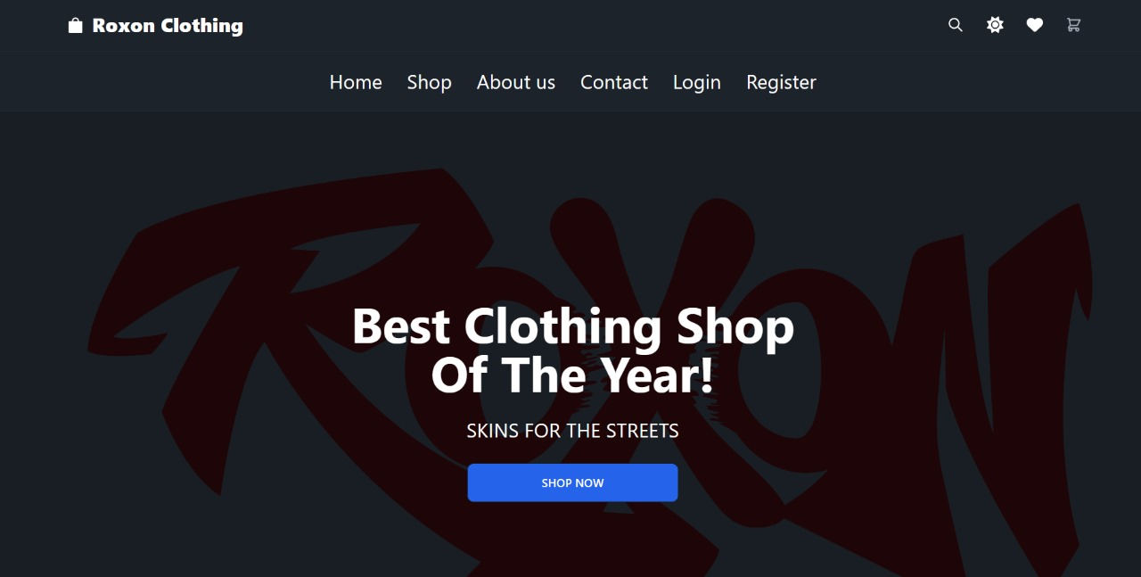

Fig 6.1 Front page

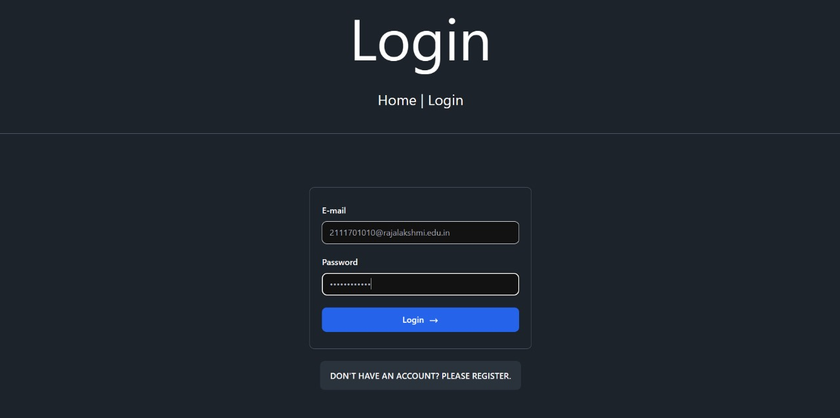

Fig 6.2 Login page

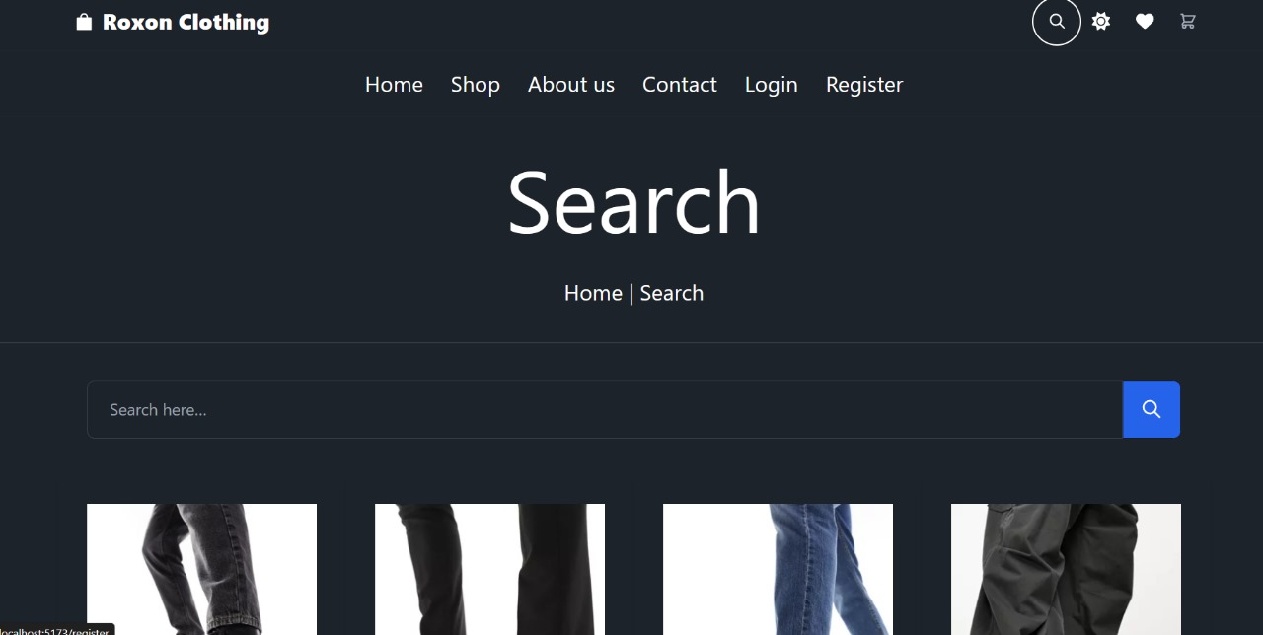

Fig 6.3 Search Page

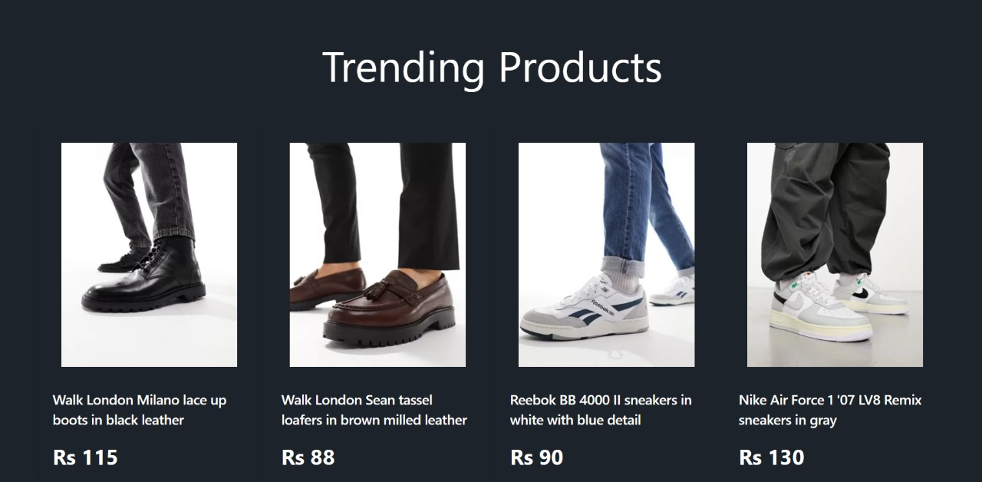

Fig 6.4 For you page

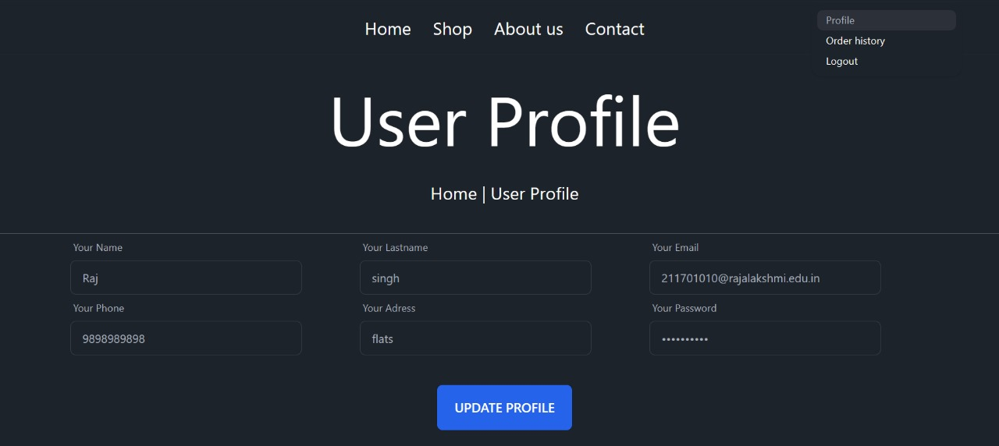

Fig 6.5 User Profile

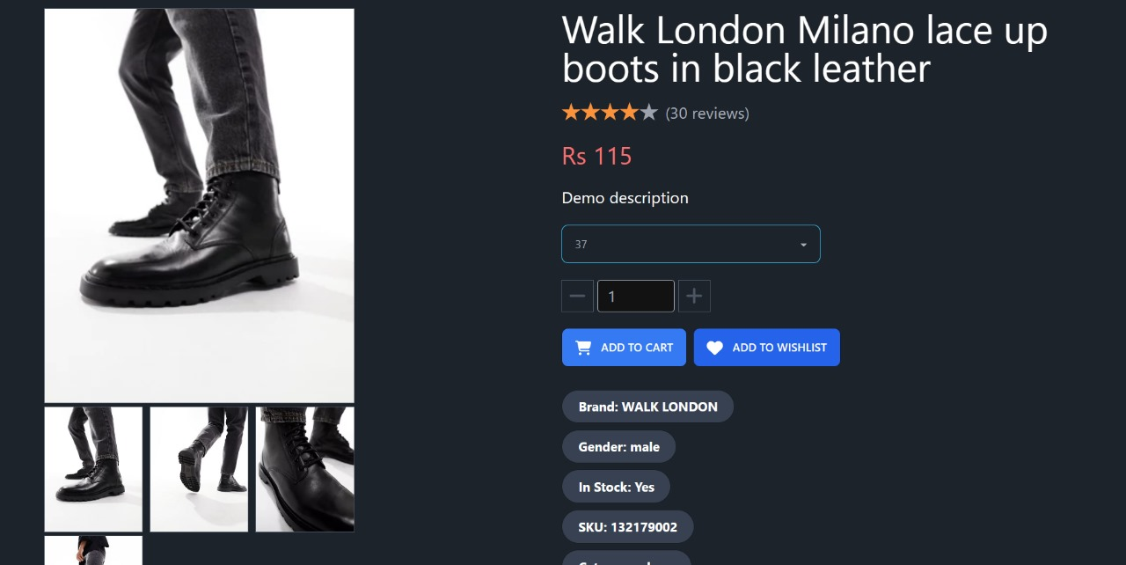

Fig 6.6 View Product

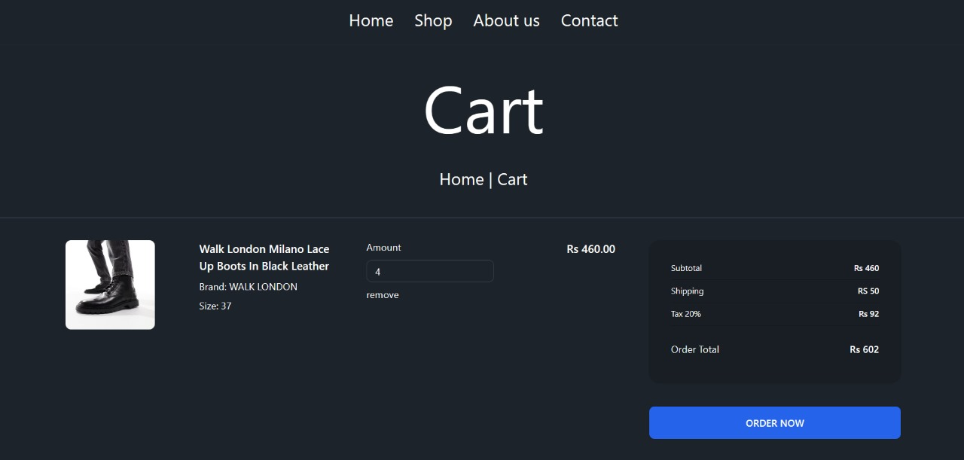

Fig 6.7 Add to Cart details

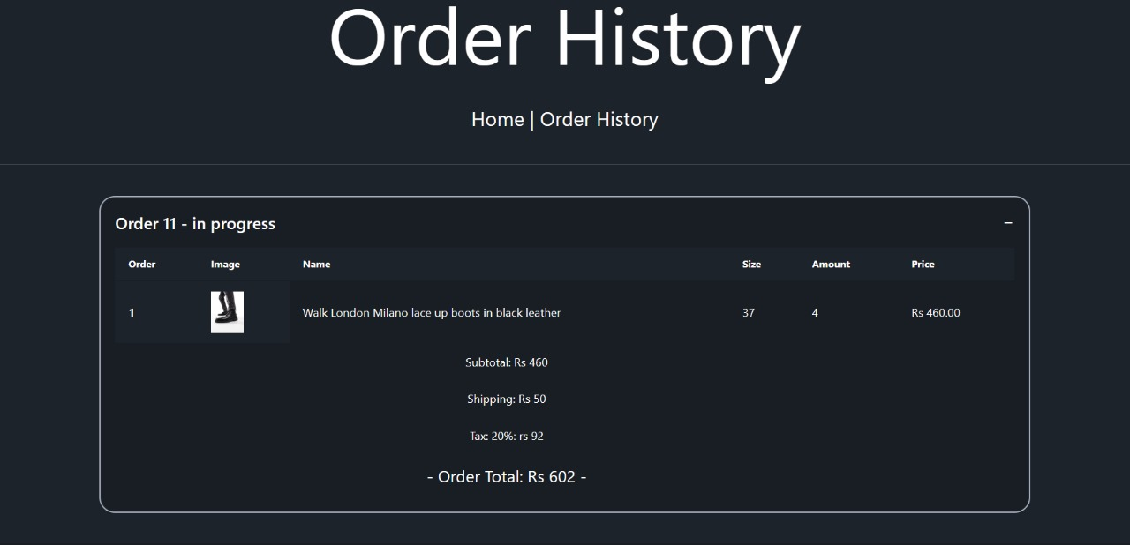

Fig 6.8 Order History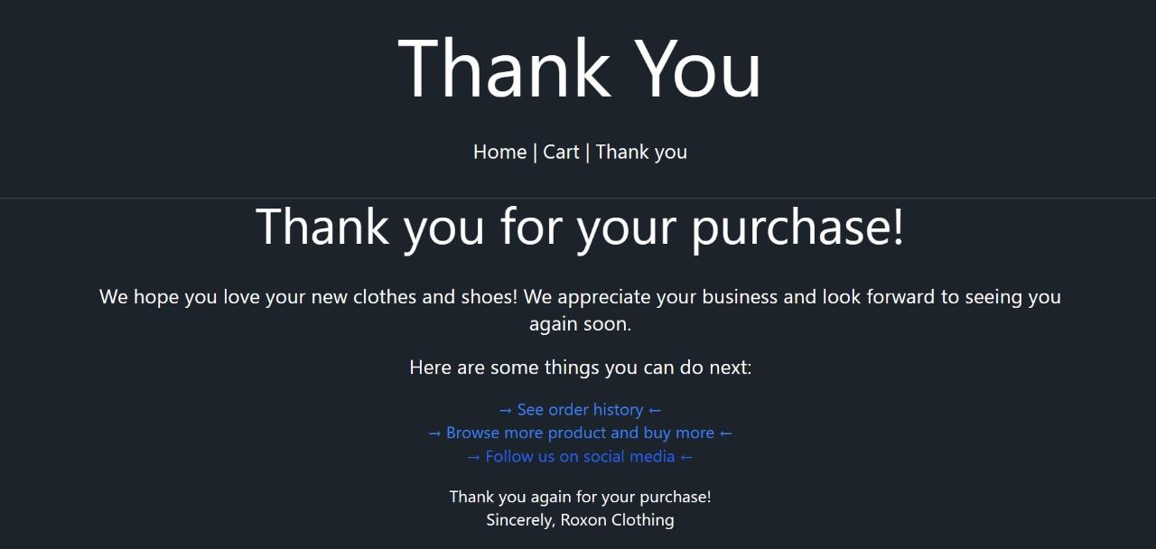

Fig 6.9 Thank You page

# CHAPTER 6 CONCLUSION

In conclusion, the e-commerce shoe selling website, ROXON, leverages the power of React, Redux, and normal CSS to provide a seamless and engaging shopping experience. By integrating React, the website offers dynamic user interfaces with efficient rendering and component reusability, enhancing performance and user interaction. Redux centralizes state management, ensuring predictable state updates and facilitating efficient data flow between components. This enables ROXON to handle complex state logic effectively, ensuring a smooth and responsive user experience.

Moreover, styling with normal CSS allows ROXON to achieve a visually appealing design that reflects the brand's identity while maintaining consistency and accessibility across different devices. Through intuitive navigation, high-quality product displays, and personalized recommendations, ROXON caters to the diverse needs and preferences of its customers, fostering engagement and driving sales.

By combining these technologies, ROXON not only provides a user-friendly platform for browsing and purchasing footwear but also establishes a robust foundation for scalability and maintainability. With ongoing enhancements and optimizations, ROXON is poised to continue delivering exceptional service standards and cementing its position as a premier destination for online shoe shopping.

# REFERENCES

1. **Shoppers Stop -** [**https://www.shoppersstop.com/men-footwear/c-A1030**](https://www.shoppersstop.com/men-footwear/c-A1030)
2. **Metro Shoes -** [**https://www.metroshoes.com/**](https://www.metroshoes.com/)
3. **Skechers -** [**https://www.skechers.in/**](%20https:/www.skechers.in/)
4. **Mochi Shoes -** [**https://www.mochishoes.com/**](https://www.mochishoes.com/)